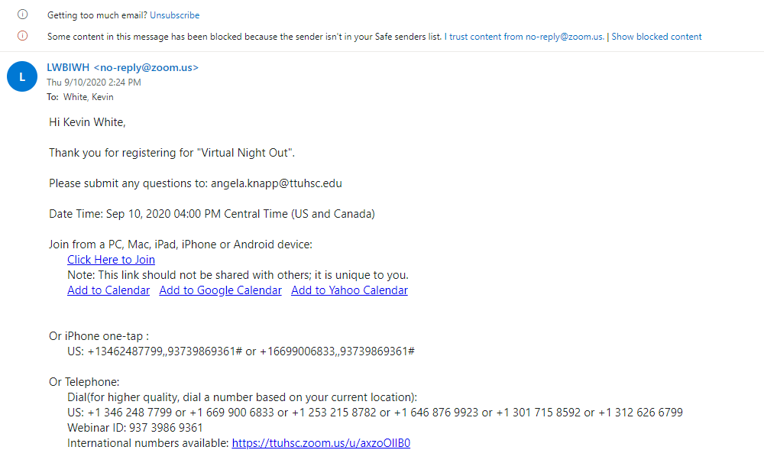

I joined the virtual night out and was able to connect with other students and learn how to manage collage life, I learned how I should look at things and how to persevere through a negative mindset and how to and change my prospective on the events that always don’t go in my favor. I need to take advantage of a situation and not worry about being pessimistic or optimistic, I need to worry about being an opportunist.